Student’s name | …………………………………………………….…… | Grade | 5
Subject | Computer | Week No. | 12
Lesson Title | Slide Master | Unit
Worksheet No. ( 12 )

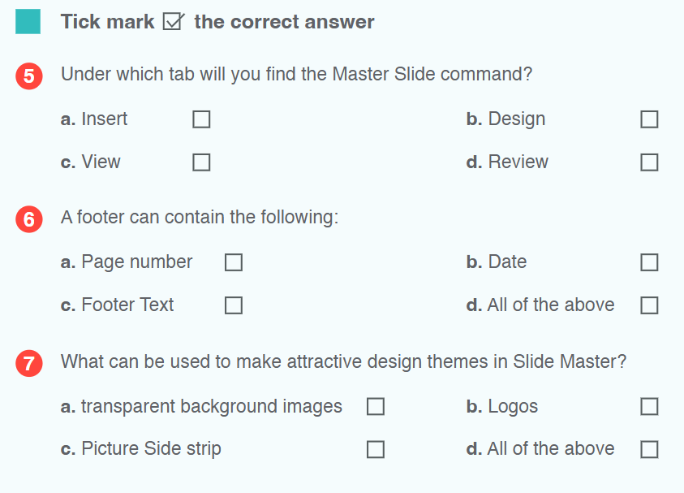
Question A:

Good Luck

